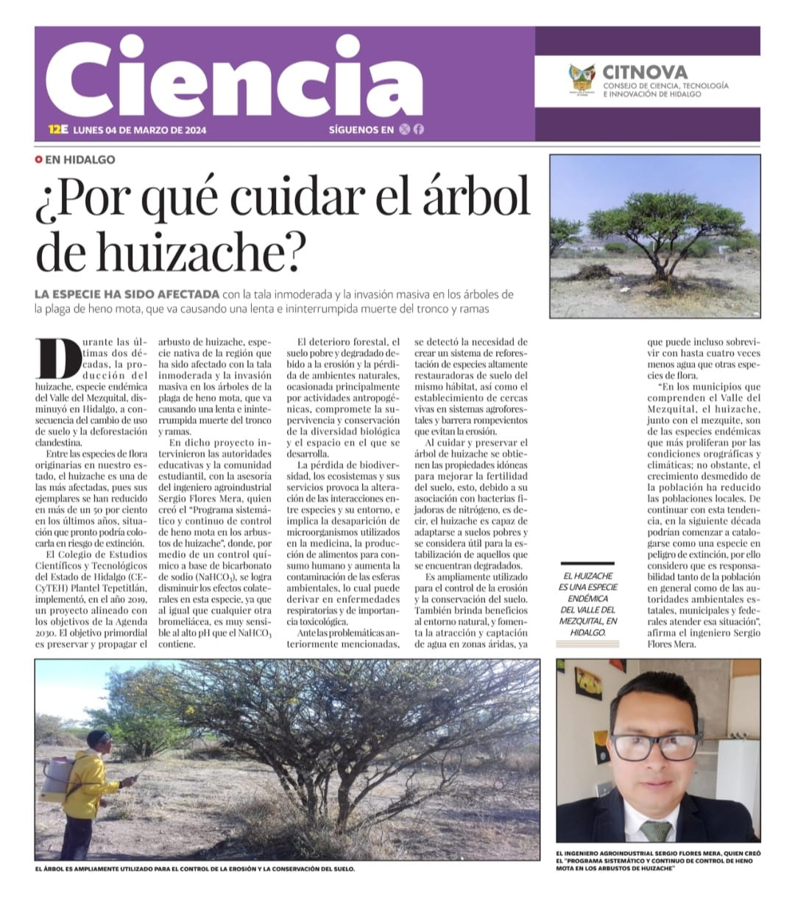
Article source: Plaza Juarez
See English translation below.

Plaza Juarez, March 4, 2024
Why Care for the Huizache Tree?
Author: Agribusiness Engineer Sergio Flores Mera who created the “systemic and continuous control program of heno mota (paxtle) in the Huizache”
During the last two decades, the production of Huizache, an endemic species of the Mexquital Valley, decreased in Hidalgo, as a result of the change in land use and clandestine deforestation.
Among the flora species native to our state, the Huizache is one of the most affected, since its specimens have been reduced by more than 50 percent in recent years, a situation that could soon place it at risk for extinction.
The College of Scientific and Technological Studies of the State of Hidalgo (CECyTEN) Plantel Tepetitlan, implemented in 2019, a project aligned with the objectives of the 2030 Agenda. The primary objective is to preserve and propagate the Huizache bush, a species native to the region that has been affected by excessive logging and the massive invasion of the trees by the heno mota (paxtle) pest, which causes a slow and uninterrupted death of the trunk and branches.
Through a chemical control based on sodium carbonate (NaHCO3) it is possible to reduce the side effects in this species, since like any other bromeliad, it is very sensitive to the high pH, that sodium carbonate contains.
Forest deterioration, poor and degraded soil due to erosion and loss of natural environments, caused mainly by anthropogenic activities, compromises the survival and conservation of biological diversity and the space in which it exists.
The loss of biodiversity, ecosystems and their services causes the alteration of interactions between species and their environment, and implies the disappearance of microorganisms used in medicine, the production of food for human consumption and increases pollution of environmental spheres, which can lead to respiratory and other important diseases.
Given the problems mentioned above, the need to create a reforestation system of highly soil-restoring species of the same habitat was detected, as well as the establishment of living fences in agroforestry systems and windbreak barriers that prevent erosion.
By caring for and preserving the Huizache tree, the ideal properties are obtained to improve soil fertility, due to its association with nitrogen-fixing bacteria that is considered useful for the stabilization of those who are degraded.
It is widely used for erosion control ad soil conservation. It also provides benefits the natural environment, and promotes the attraction and capture of water in arid areas, since it can even survive with up to four times less water than other species of flora.
In the municipalities that comprise the Mezquital Valley, the Huizache, along with mesquite, are one of the endemic species that proliferate the most due to the orographic and climatic conditions, however, the excessive growth of the population and reduced local populations. If we continue with this trend, I the next decade they could begin to be classified as a species in danger of extinction, which is why I consider that it is the responsibility of both the population in general and the State, municipal and federal environmental authorities address this situation.

